Old vs New.
Through the years I’ve chopped down a lot of trees. Through the years I’ve limbed and sectioned a lot of trees I’ve chopped down. Through the years I’ve split a lot of wood that I’ve limbed and sectioned having chopped trees down.
But in every case I’ve only ever processed trees with either hand tools or modern power tools. Pretty much every time, I’ve wondered which would actually be quicker? Hand or power?
Whilst on a recent but regular family ‘wooding day’ I set about a completely unofficial and absolutely scientifically useless quest to find the answer.
To clarify, this article is not a’ how to’ demonstration of safe and decent practise with either hand or power tools – just my own cerebal wafflings in an attempt to answer a question that has bugged me for a long time.

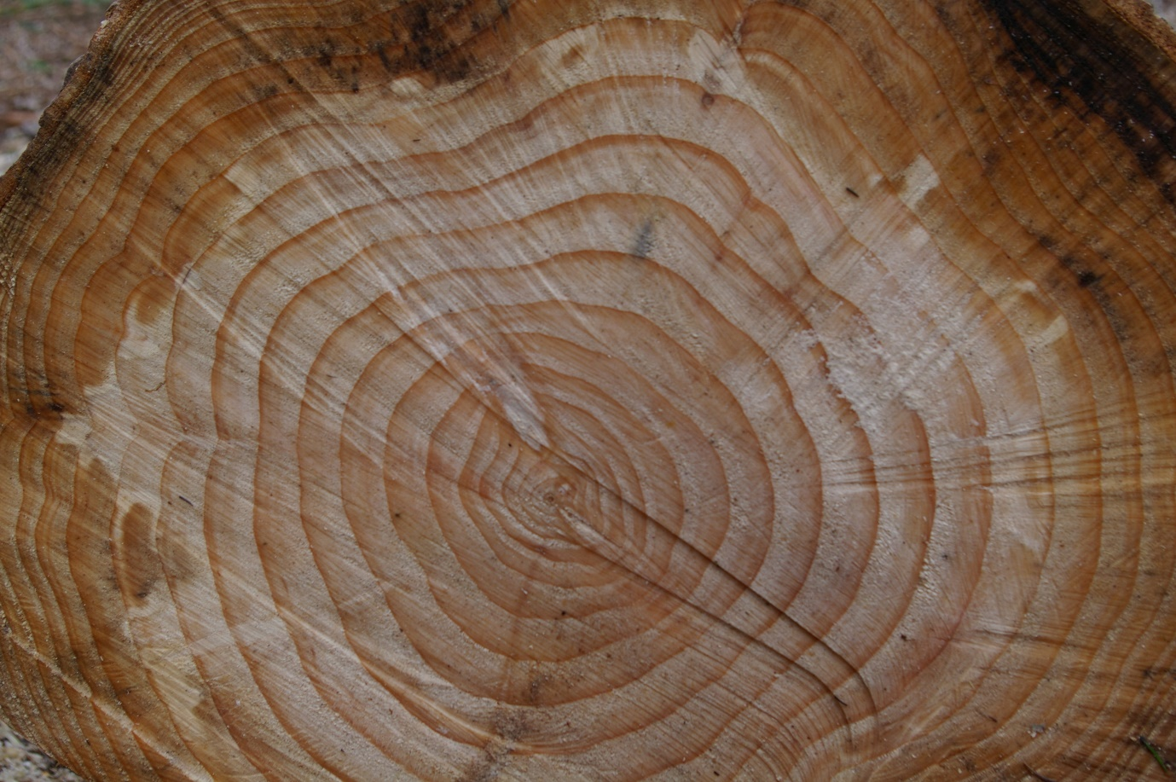

James’ predictions:

Felling - power tools.
Limbing – power tools? Hand tools? Don’t know.
Sectioning – big win for power tools. Also, sore arms for hand tools.
Splitting – hand tools. Maybe. Or maybe not.
Overall winner? Ask me at the end.

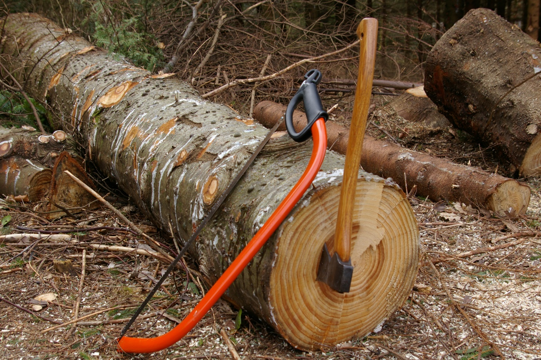

Now – an obvious flaw and to pre-empt any comments to the negative. Yes, of course, should I have to transport the wood I’d collected back to the log store without the use of modern motor vehicles then ‘power’ would win. But my question is purely about felling, limbing, sectioning and then splitting the wood for stacking. Transport is out of the equation.
Also, I’m not going to get too hung up on a specific cubic volume of wood. Trees selected are from the same plantation, grown in the same conditions and of the same age so give and take they were the same. Once felled, I measured out 20 ft of trunk, the length being the benchmark in this case.

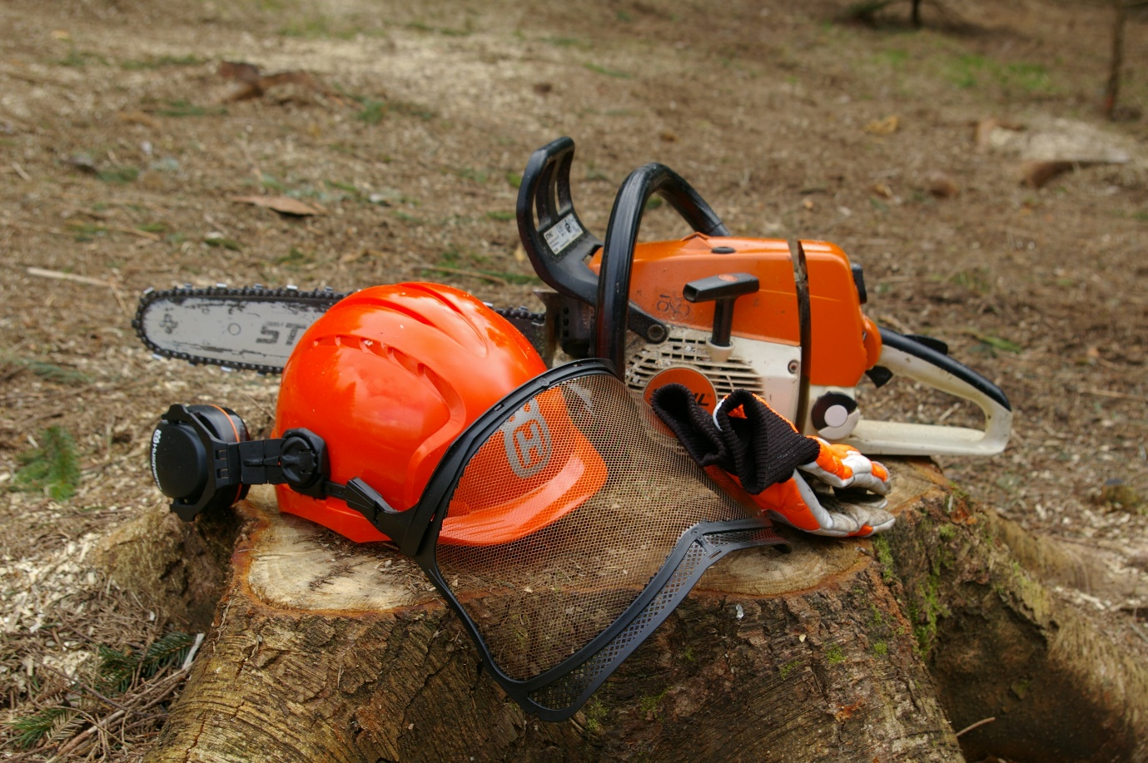

With the clock started, and suitably dressed, the experiment began with the first tree felled by chainsaw. I wasn’t working at a crazy racing pace, but just a pace that would be realistic and allow a full day’s heavy work – aside from that I like my fingers/hands/legs/arms/head where they are and racing with a chainsaw will only end seeing red.

And so the day continued with a tree felled by axe and bow saw.
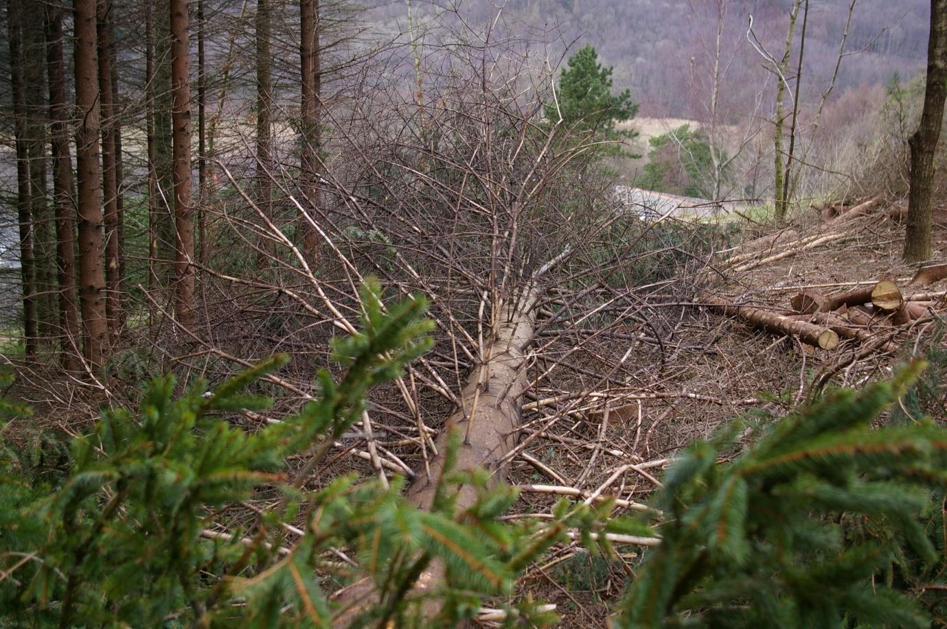
20 ft of log measured on each of the fallen trees, they were then both limbed. All times are printed at the end of this article yet this, in my dull world, proved the most exciting part of the competition.

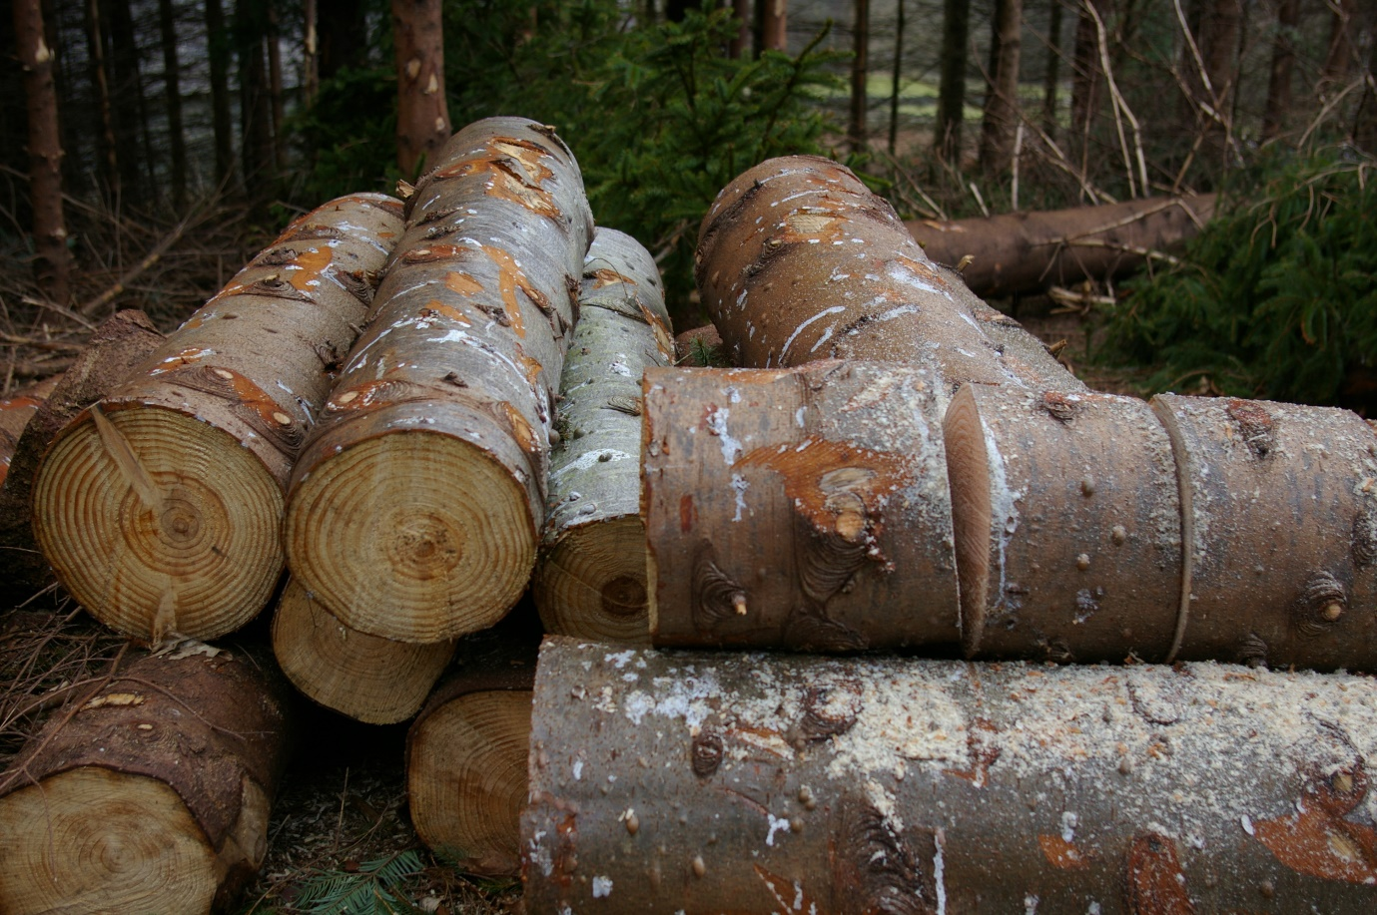
In my mind the power tools would now start to open up a considerable lead in the sectioning – which they did. Various hurtful comments from various family members will be left unprinted with regard to my efforts put in on the bow saw.
With light fading, and plenty of extra trees processed for firewood, we called it a day in the woods and transported several trailer loads home.
Having to return to work the following day, my ‘wooding’ day continued on into the dark however. Powerful outside lights covered the final, dramatic (ish) showdown between a mechanical log splitter and trusty splitting maul.
So – the winner? See below.

Time – Power tools
Felling: 1min 42
Limbing: 2min 26 (20 ft)
Sectioning: 6min 20
Splitting: 20min 12
Total: 30min 40.

Time – Hand tools
Felling: 3min 57
Limbing: 2min 28
Sectioning: 36min 40
Splitting: 13min 20
Total: 56min 25.

So the overall winner was power tools by a closer margin then certainly I would have thought. A valiant attempt from hand tools in the splitting section and a very near miss in the limbing section are of worthy mention though.
Modern power tools can of course make our life easier, even in the woods. The times above speak for themselves – especially in the sectioning part of the experiment. No human could get anywhere near to matching the speed of processing from a chainsaw in this case. However loud and maybe a bit scary, I really enjoy using chainsaws.
On the other hand, nothing beats using an axe in my book. I generally am a bit old fashioned and simply adore swinging an axe. I always knew it would be close but the results differing only by 2 seconds for the limbing section will now make me put the chainsaw down and use an axe in future.
Hand tools certainly feel more in keeping with being in the woods. With ear defenders, a sweaty helmet, stupidly heavy trousers and boots on, you can’t help but feeling like a kind of an invader in the quiet beauty of woodland when revving a chainsaw.
I love our wooding days out. It brings together the family in a beautiful part of the world and we have fun, all in the name of collecting wood which will be dried and then later used to fuel stoves and open fires in the cold and wet winter months sometime in the future. Sad as it is to admit, I love working hard as well – even on a family day out. Most of us have a weird bug – the wooding bug we call it – and I’ve a bad case of the same.
In all honesty there is nowhere I would prefer to be, and with no other people when I get the call to go wooding. But give me a couple of days before the next one – my arms are done for the moment.

